Descriptive Analytics Report: PhonePe
Daily Transaction Behavior at Scale

Name: Anamika Gupta
Roll no: 1250258079
Course: BCA (DS& AI)
Section: BCADS27
Date: 10th August, 2026

Tracking Transaction Trends, Payment Categories, Success Rates, Regional Demand & Operational Status

Note on data: This report uses the supplied PhonePe dataset containing 200 records across 5 dates, 8 states and 6 payment categories. The dataset is already aggregated rather than raw event-level transaction data. Therefore, the analysis describes the supplied observations and does not assume a larger real-time PhonePe transaction stream.

1. Objective
Build a descriptive analytics layer over PhonePe transaction data to answer following recurring business questions:
- How are daily transaction volumes trending over time?
- How are daily GMV trending over time?
- Which payment category contributes the highest transaction volume?
- Which payment categories contribute the most to overall GMV?
- Which states generate the highest transaction volumes?
- Which states contribute the most GMV?
- How successful are transactions, and what is the customer satisfaction level?
- Where is transaction demand concentrated geographically?
- How does customer satisfaction (CSAT) vary across states?
- How does active merchant activity relate to transaction volume?
- How do weekday and weekend transaction patterns differ?

2. How This Would Work at Real Scale
Processing large-scale digital-payment events is an engineering problem before it is an analytics problem. A realistic architecture would collect transaction events, aggregate them by time/category/state, store raw and aggregated data, and expose the resulting KPIs through a BI layer.
Layer | Purpose | Typical tools
Investigation | Capture transaction events in real time | Python & Excel
Stream processing | Aggregate by category, state and time
Storage | Retain raw and aggregated data
Batch aggregation | Daily KPI and reconciliation rollups
Report | Dashboards refreshed hourly or daily | Data Visualization

3. Daily Transaction Volume
Over the supplied 5-day window, the dataset records 23,853,873 transactions and approximately ₹1,428.14 crore in GMV. The daily charts below show how transaction volume and GMV move across the available dates.
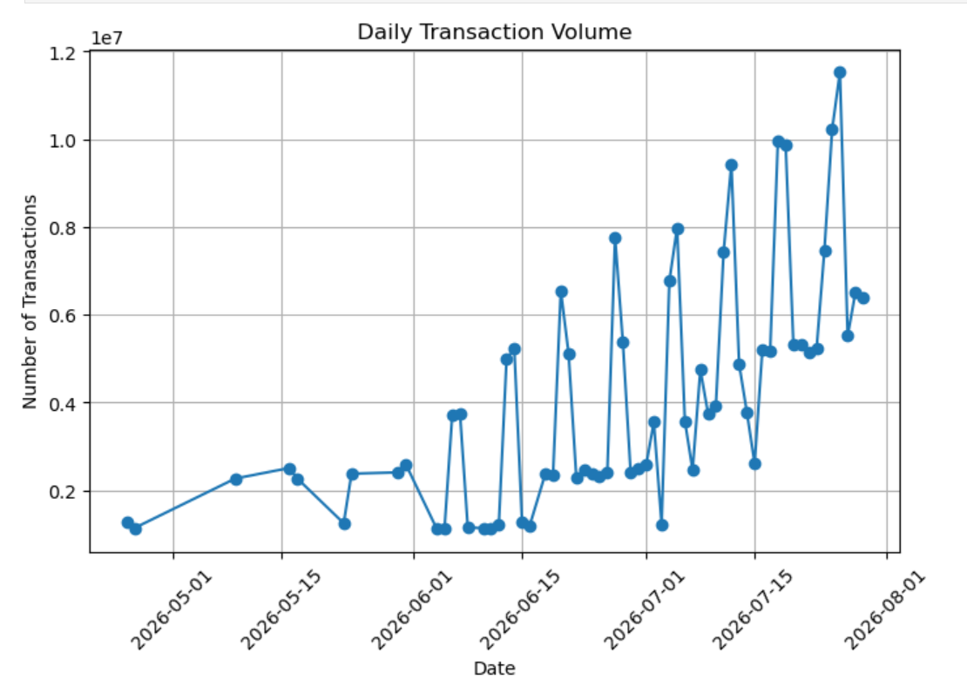
Figure 1. Daily transaction volume

4. Daily GMV trending over time

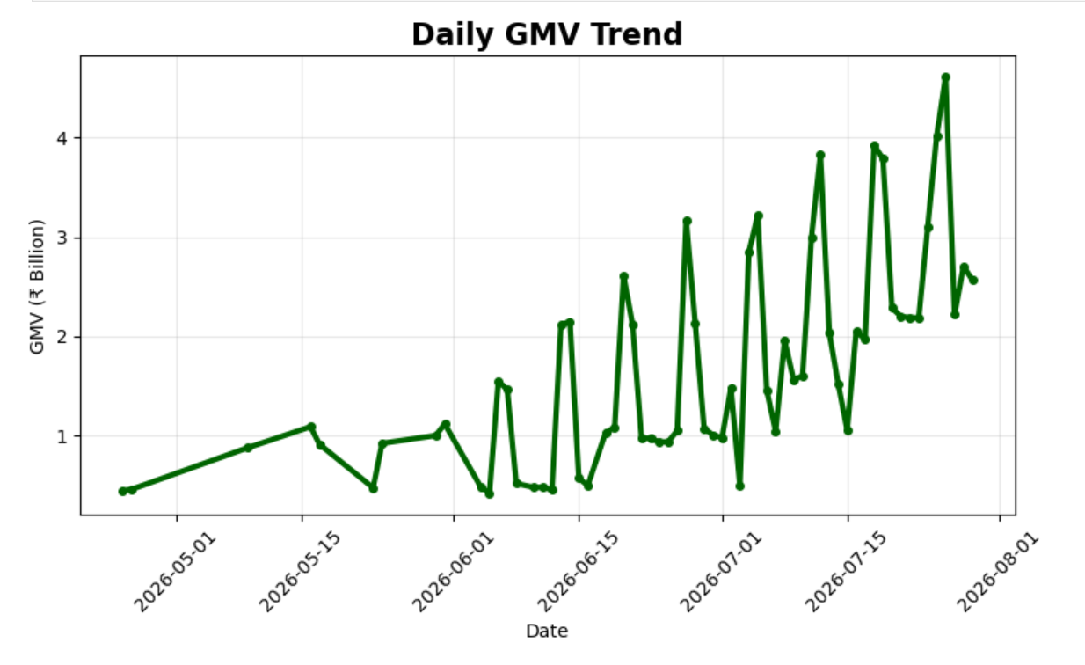
Figure 2. Daily GMV trend

5. Best-Performing Payment Categories
UPI - Merchant/QR is the leading payment category by transaction volume with 14,746,630 transactions, followed by UPI - P2P with 6,597,654. The ranking here is based on transaction count rather than GMV, because volume and monetary value answer different business questions.
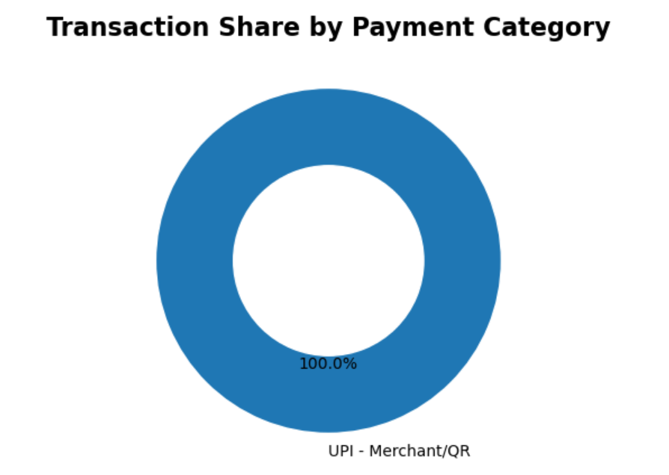
Figure 3. Transaction share by payment category

6. Payment categories contribute the most to overall GMV

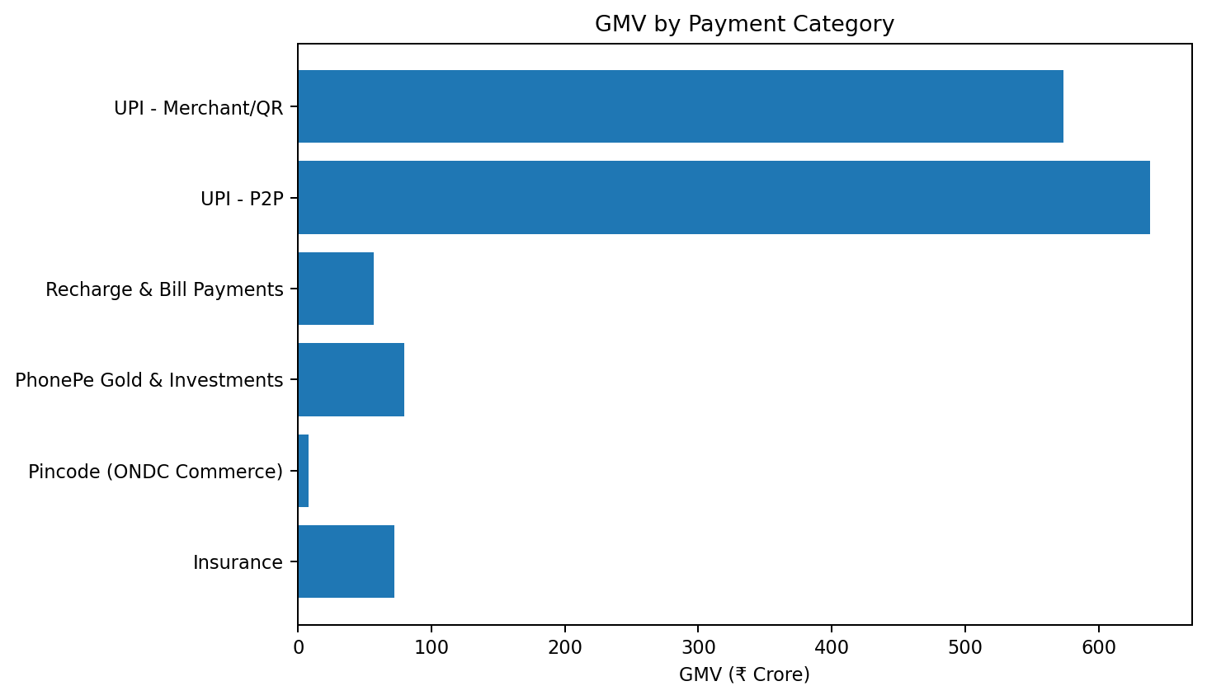
Figure 4. GMV by payment category

8. Success Rate & Customer Satisfaction
The average transaction success rate across the supplied records is 97.96%, while the average CSAT score is 4.62/5. Success rate is an operational reliability metric, whereas CSAT reflects the customer experience captured in the dataset.
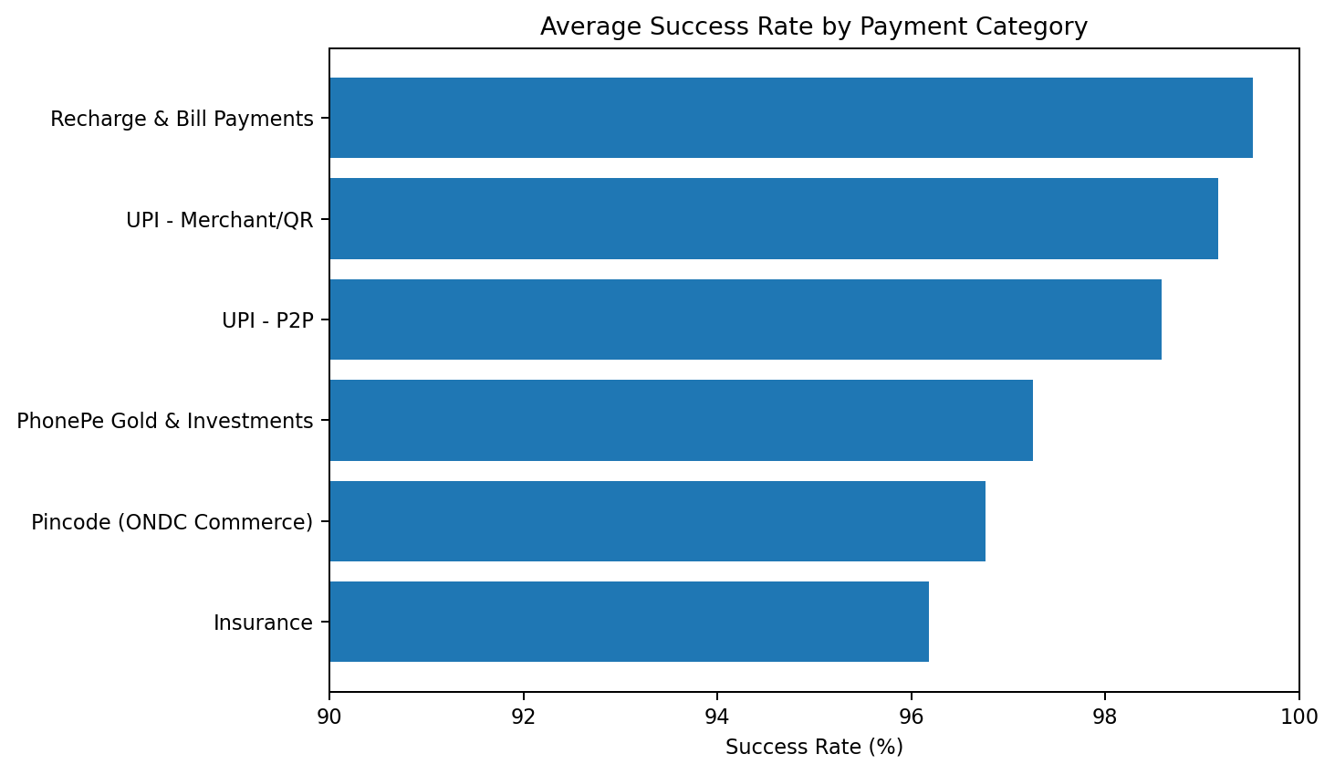
Figure 5. Average success rate by payment category
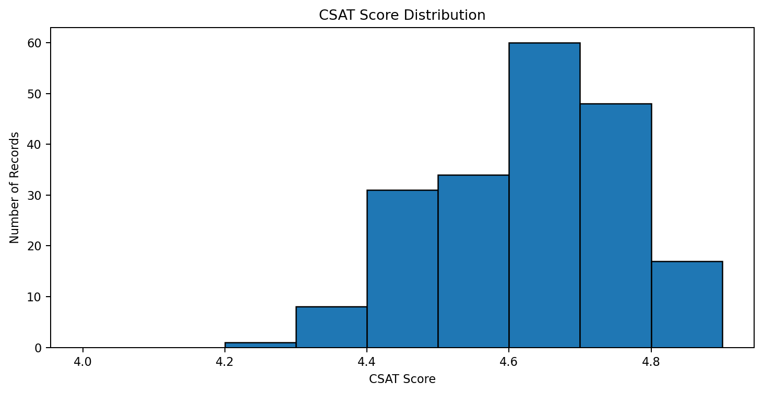
Figure 6. CSAT score distribution

6. Regional Demand
Transaction demand is distributed across 8 states. Maharashtra has the highest transaction volume in the supplied data at 3,802,979 transactions. Regional demand analysis can support merchant coverage, operational planning, service monitoring and state-level business decisions.
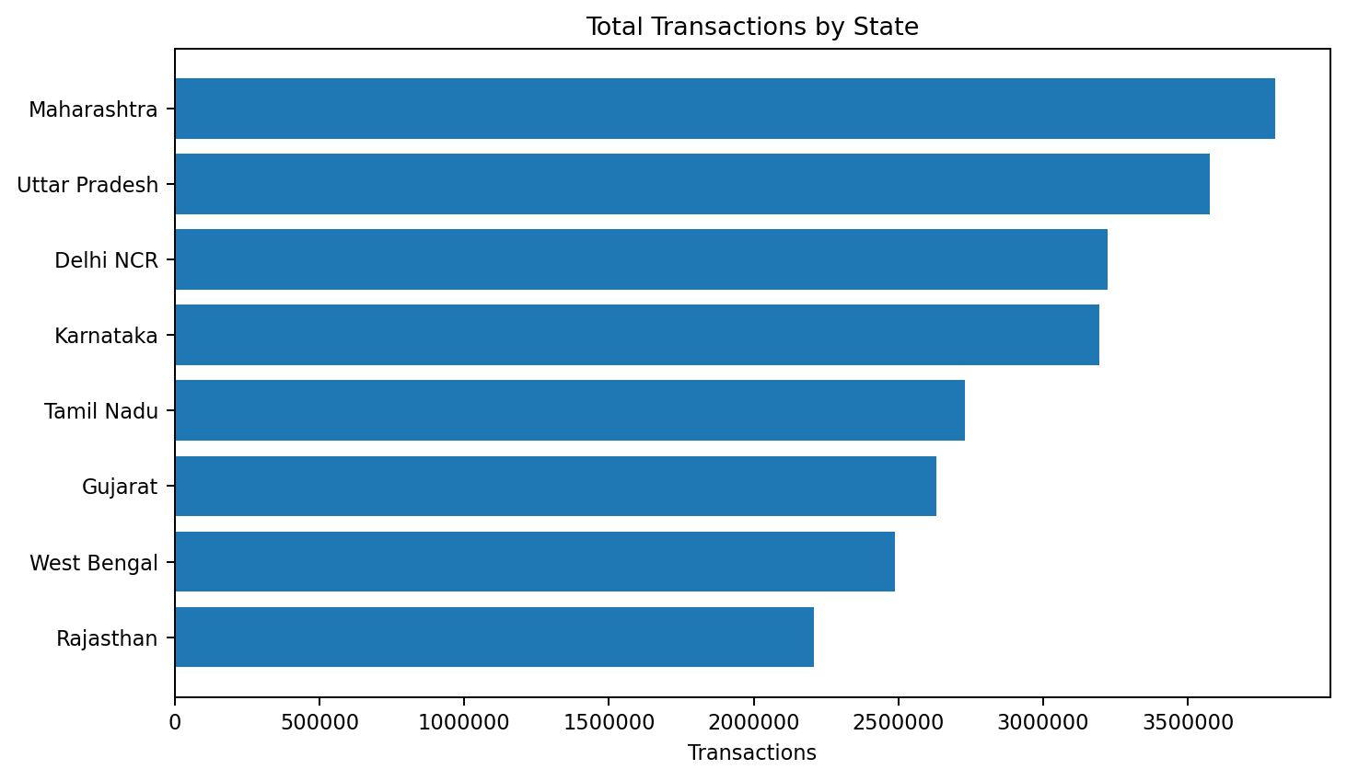
Figure 7. Total transactions by state

7. Operational / Downtime Status
No supplied record is flagged for downtime. This means the downtime_flag column contains zero flagged observations in this dataset. This should not be interpreted as proof that PhonePe experienced no downtime outside the supplied sample.
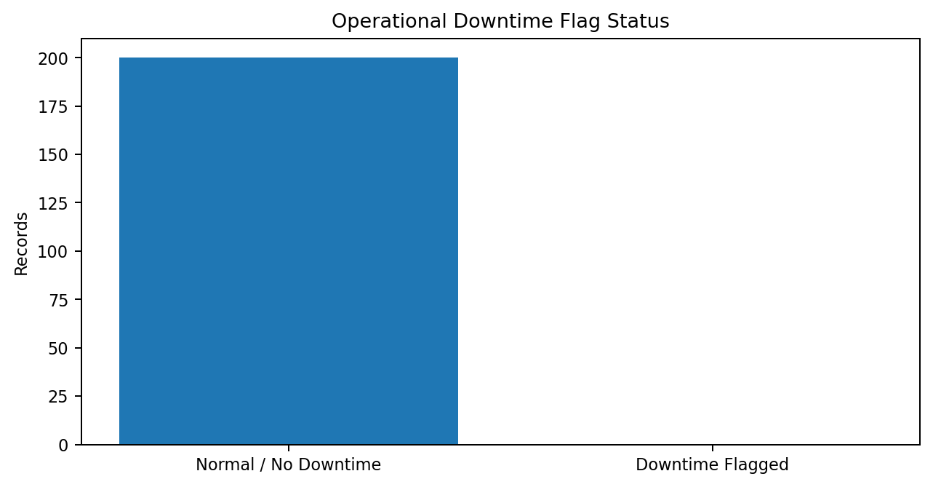
Figure 8. Downtime flag status

8. Summary of Key Metrics
Metric | Value
Total transactions | 23,853,873
Total GMV | ₹1,428.14 crore
Average success rate | 97.96%
Average CSAT score | 4.62 / 5
States tracked | 8
Payment categories tracked | 6
Dataset records | 200
Downtime-flagged records | 0

9. Active Merchants vs Transaction Volume
The relationship between active merchants and transaction volume provides an additional descriptive view of state-level activity. States with more active merchants may generate higher transaction volumes, but the scatter plot should be interpreted as association rather than proof of causation.
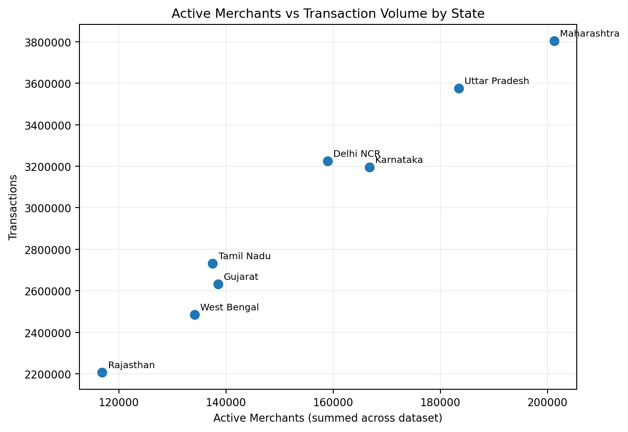
Figure 9. Active merchants vs transaction volume by state

10. Next Steps to Move From Descriptive → Predictive
- Demand forecasting by state and payment category to estimate future transaction volumes.
- Anomaly detection for sudden changes in success rate, GMV or transaction volume.
- Downtime-impact analysis linking operational flags to transaction failures and lost GMV.
- Merchant productivity analysis using transactions per active merchant.
- Trend and cohort analysis when longer historical data becomes available.
This report answers what happened in the supplied dataset. The next analytical layer would use a longer time period and richer event-level data to explain why changes occurred and to forecast what is likely to happen next.

